SpecterX for Slack: Onboarding & User Guide
This guide covers the installation, configuration, and usage of the SpecterX bot to secure and redact file attachments within your Slack workspace.

Overview
The SpecterX for Slack is designed to achieve secure file governance within Slack by ensuring that no unprotected files remain in monitored channels. Its core mission is to automatically intercept file uploads, replace them with secure, SpecterX-protected links, and enforce consistent file access controls based on channel membership. The goal is to preserve conversation flow by rewriting messages naturally, without disrupting user experience.Capabilities and V1 Behavior

When a file is uploaded in a monitored channel, the connector operates by:
- Interception and Replacement: It immediately intercepts the Slack event, downloads the file, removes the original file from the message, and stores the file in the customer’s SpecterX-integrated storage. It then rewrites the Slack message to insert a protected SpecterX link.
- Automatic Access Control: The user who uploads the file is automatically assigned as the Data Owner. All current members of the channel at the time of the upload become the designated Recipients for that link, enforcing access control immediately. Link access and policies can be updated later via the SpecterX Web UI.
- Scope: Enforcement is applied to file uploads only (not message-only content) within explicitly monitored channels (where the app was manually added).

Note: Once a file is protected, Slack's native file previews, unfurls, and file search capabilities are no longer supported.

Installation and Configuration for the Admin
Currently, the SpecterX for Slack is deployed as a custom integration using a Slack App Manifest. This allows you to retain full control over the app's permissions within your workspace.

Prerequisites
- Workspace Administrator or Owner role.
- The manifest.json file provided by the SpecterX team.

Step-by-Step Installation
- Create the App
  - Navigate to api.slack.com/apps.
  - Click Create New App.
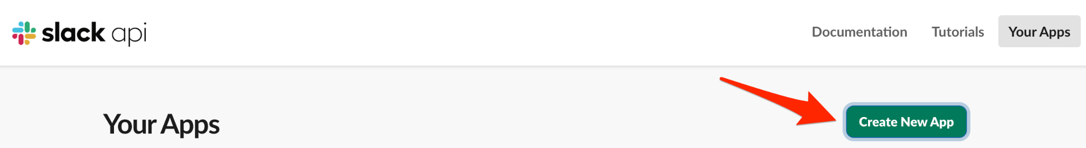
  - Select From an app manifest.
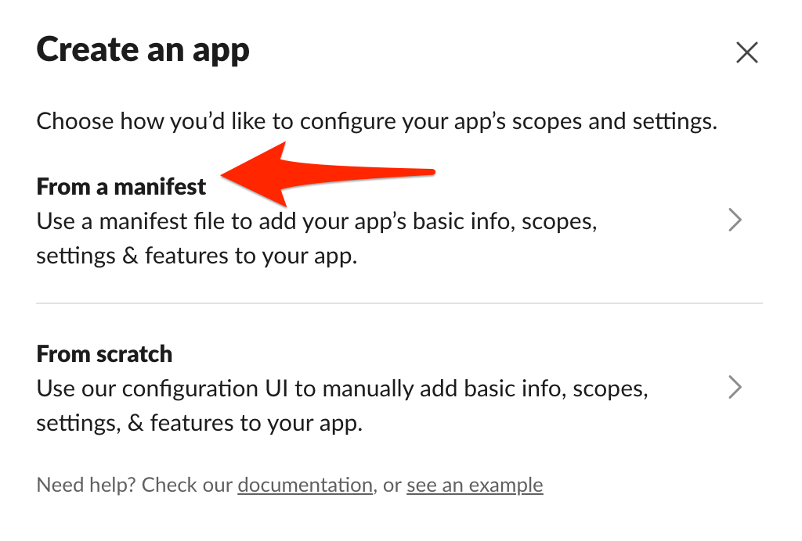
  - Select your target workspace.
  - Paste the contents of the manifest.json file provided by SpecterX (ensure placeholder values like URLs are updated if required).
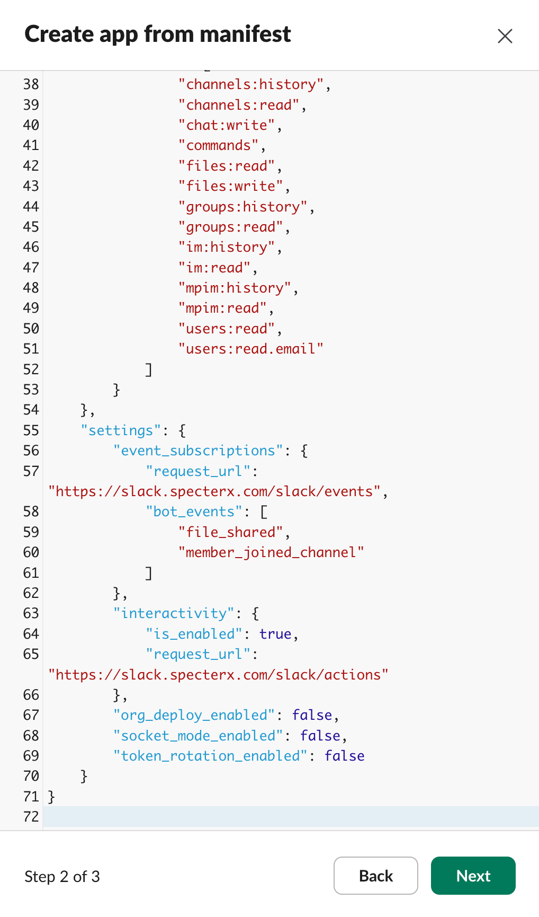
  - Click Create.

- Install to Workspace
  - On the ‘OAuth & Permissions’ tab, proceed to Install App.
  - Click Install to Workspace.
  - Review the permissions and click Allow.

Required Permissions (Scopes)
The app requires specific permissions to function. These are defined in the manifest but are summarized here for your review:

Bot Scopes (What the app can do):
- channels:history, groups:history, im:history: To see when files are shared.
- files:read, files:write: To download shared files for scanning and delete the original insecure copy.
- chat:write: To post replacement messages and notifications.
- users:read, users:read.email: To match Slack users with their SpecterX accounts.

User Scopes (Why users authorize):
- chat:write, files:write: To allow the bot to edit the original user's message, replacing the raw file with a secure SpecterX link seamlessly.

Configuration
Once the app is installed, you need to provide the following credentials to your SpecterX deployment configuration (or share them securely with your SpecterX account manager):
- Client ID & Client Secret (Found under Basic Information)
- Signing Secret (Found under Basic Information)
- Bot User OAuth Token (Found under OAuth & Permissions - starts with xoxb-)
- User OAuth Token (Found under OAuth & Permissions - starts with xoxp-)

Adding to Channels
To activate SpecterX protection, the bot must be added to specific channels.
- Public/Private Channels: Go to the channel and type /invite @SpecterX for Slack.
- DMs: The bot currently only works in Channels. (See Roadmap for DM support).

What Happens in the Channel?
Once the bot is added, it monitors for file uploads. The behavior for handling these files depends on whether the user is authenticated with the SpecterX connector:

If the user is authenticated:
- The message body will be edited directly, the original file(s) will be removed, and SpecterX-protected links will be inserted in their place, within the original message.
- This ensures a seamless, native-feeling experience for users who are already authorized.
If the user is not yet authenticated:
- Files will be removed from the message, but the message itself will not be edited.
- Instead, the SpecterX-protected links will be posted as a reply in the message thread.
- If the original message was sent in a thread, the links will be posted in the same thread.
- Additionally, the user receives an ephemeral prompt (only visible to them) to authorize the app to edit their messages.

User Onboarding (How to Authorize)
As described above, authentication provides the best user experience (seamless message editing). Users can authorize the app in two ways:
- Interactive Prompt: When an unauthenticated user shares a file in a protected channel, they will automatically receive an ephemeral prompt with an Authorize with Slack button.
- Slash Command: Users can proactive authorize at any time by typing /specterx-authorize in any channel.

Roadmap - Enterprise Discovery Integration
We are actively developing our Enterprise DLP offering for customers on Slack Enterprise Grid. This major effort is currently planned for a release later in 2026, allowing us to continue to invest in and improve the current Standard Protection Connector.

Coming Soon: SpecterX Discovery Integration
While the current Standard Bot offers robust channel protection, our upcoming Discovery API integration will introduce "Protection Everywhere":
- Zero-Touch Deployment: Installed once at the Org level. No need to invite the bot to individual channels.
- DM Protection: Full visibility and protection for Direct Messages and private groups without user intervention.
- Invisible Operation: The app operates silently in the background without appearing in channel member lists.
- Admin-Only Control: Cannot be removed or kicked by standard users.

Contact your SpecterX representative to learn more about our Enterprise Grid roadmap.

